**DTCS-620: Statistics for Data Science**

New York Institute of Technology

Project - I

Student Name: Niral Patel

Student ID: 1303276

Code Link: https://github.com/niral-patel/Statics-for-DS-Assignment-1/blob/main/Assingment%20-%201.ipynb

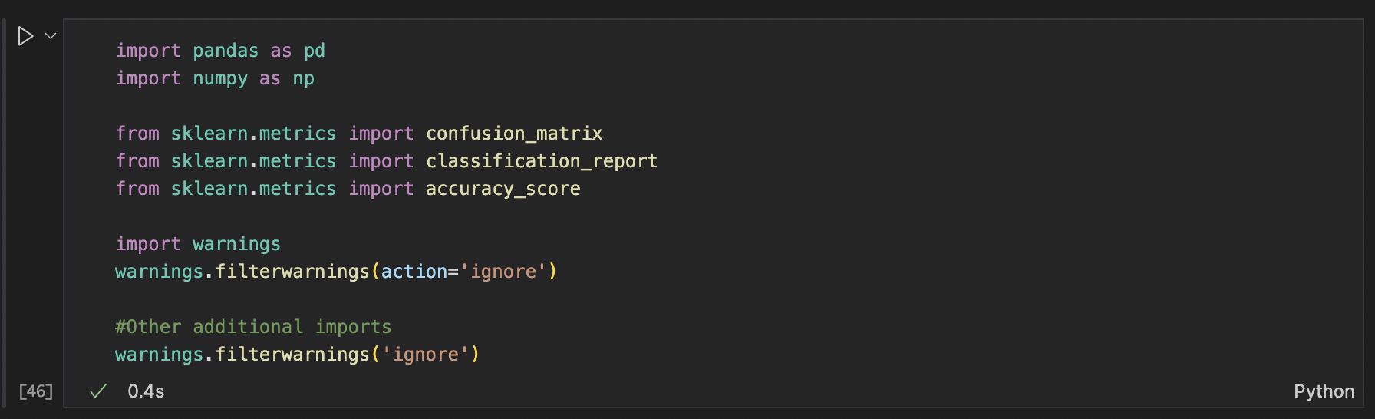To perform tasks, I import different important classes such as pandas, numpy, sklearn, etc. Moreover, to remove the warnings I imported the warnings class and use action method to ignore the filter warnings.

Now It’s time to upload the data-set and storing it in df and get more information about it by using info() method

Check the total number of Ham data and Spam data by using the pie chart and bar graph.

As per requirement, I split the data in to two parts, one is train data set which cover the first 1000 rows of data to train the model and second one is rest below 1000 rows for the testing purpose. Text

Reporting Task: 1

Compare the accuracies of the Random Forest classifier as a function of the number of base learners (e.g., 10, 50, 100, 500, 1000, and 5000) and the number of features to consider at each split (e.g., auto or sqrt). Report your observations/conclusions and provide evidence to support your conclusions.

To compare the accuracy, I created the two for loop, first loop contains features which are ‘Auto’ and ‘SQRT’, and second loop contains estimators which are ‘10, 50, 100, 500, 1000, 5000’. In those two loops I perform steps to get accuracy from ‘RandomForestClassifier’ model and store them in a Data Frame.

After performing this code, the output will show as below. As per the output the Maximum accuracy is gained when the number of base learners(n_estimators) is set to 1000 and the ‘max_features’ parameter is set to ‘sqrt’. The lowest accuracy occurs when ‘n_estimators’ parameter is set to 10 and ‘max_features’ is set to ‘auto’. In other words, when n_estimator is less the accuracy will decrease and the sqrt in max_features provide the better accuracy than auto. The accuracy result was 0.9336.

Create classification report and confusion matrix to get the precision and recall information to compare the two classification (Decision tree and Random Forest).

To compute the Decision Tree Classification, import the ‘Decisiontreeclassification’ model form sklearn library and tree class, store the model in variable and train the model and check the accuracy score using this model.

Preform the same functions to get the Classification report and confusion matrix as shown below.

Reporting Task 2:

Compare of the results of all the classifiers (with the best possible parameter setting for each classifier). Use classification accuracy (# of instances correctly classified/total # of instances presented for classification), per class classification accuracy, and confusion matrix to compare the classifiers.

As demonstrated in the code, and in the table below, I obtained Random Forest classifier as the best classifier with maximum overall accuracy,

|  |  |  |  |  |
| --- | --- | --- | --- | --- |
| Classifier | Classification Accuracy | Per Class Classification Accuracy | | Confusion Matrix |
| Precision | Recall |
| Decision Tree | 0.876 | Ham – 0.89  Spam – 0.85 | Ham – 0.90  Spam – 0.84 | array([[2001, 197],  [ 248, 1152]]) |
| Random Forest | 0.9336 | Ham – 0.93  Spam – 0.94 | Ham – 0.96  Spam – 0.89 | array([[2132, 66],  [ 125, 1275]]) |

